REVYVE V3 DESIGN REQUIREMENTS

Introduction
The Revyve WristBank is a smartwatch or fitness tracker which doubles as a power bank to provide extra battery for smartphones (at least 50% extra battery on most devices).

Last Design
Our latest design consists of two PCB’s, one labelled the “Power PCB” for power transmission, and the other labelled the “Main PCB” which stores the atmega 328p mcu, two buttons, an OLED display, a programmer, pogo pins for charging the battery, and apple lightning cable or USB-C cable for battery discharge to smartphone.

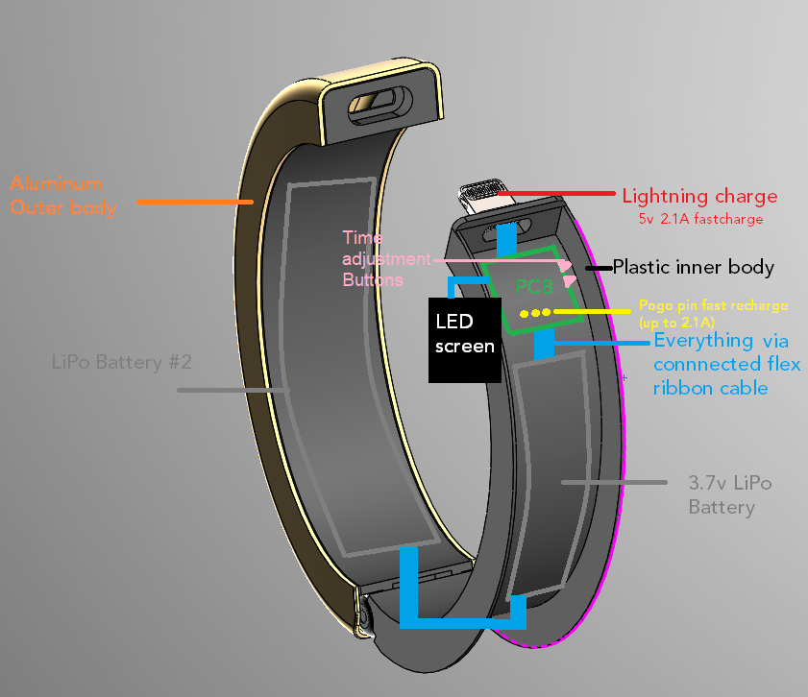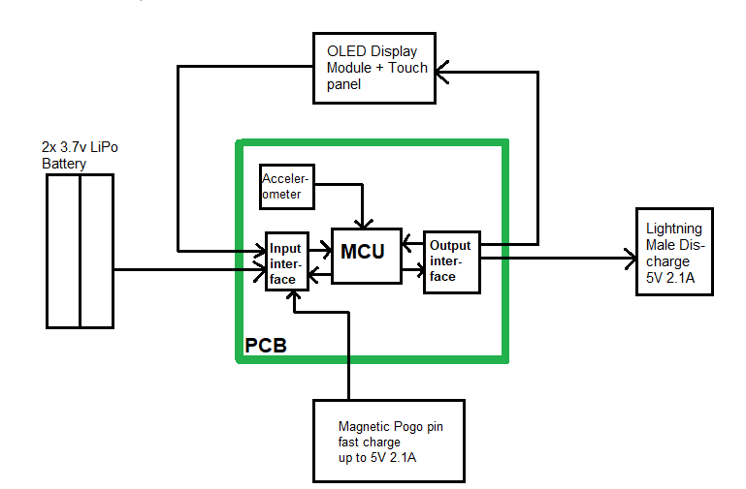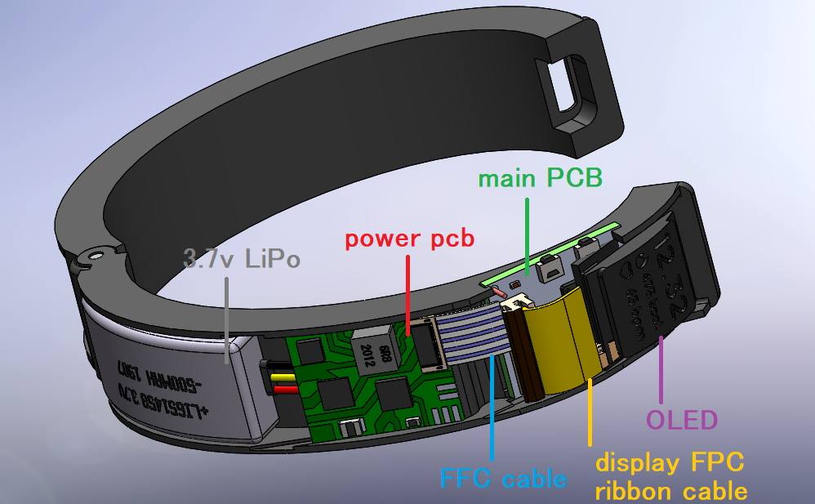

Flaws

- Power Transmission Issues:
  - One of the capacitors as shown below was apparently not proximal enough to ground so after some use the battery alone can no longer power the display. Overall the design needs to be changed to be more reliable and robust.
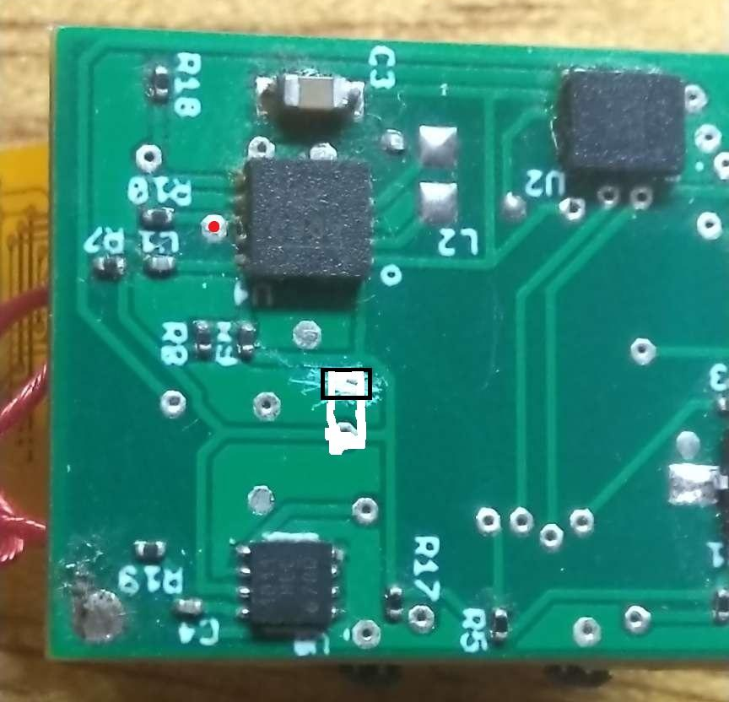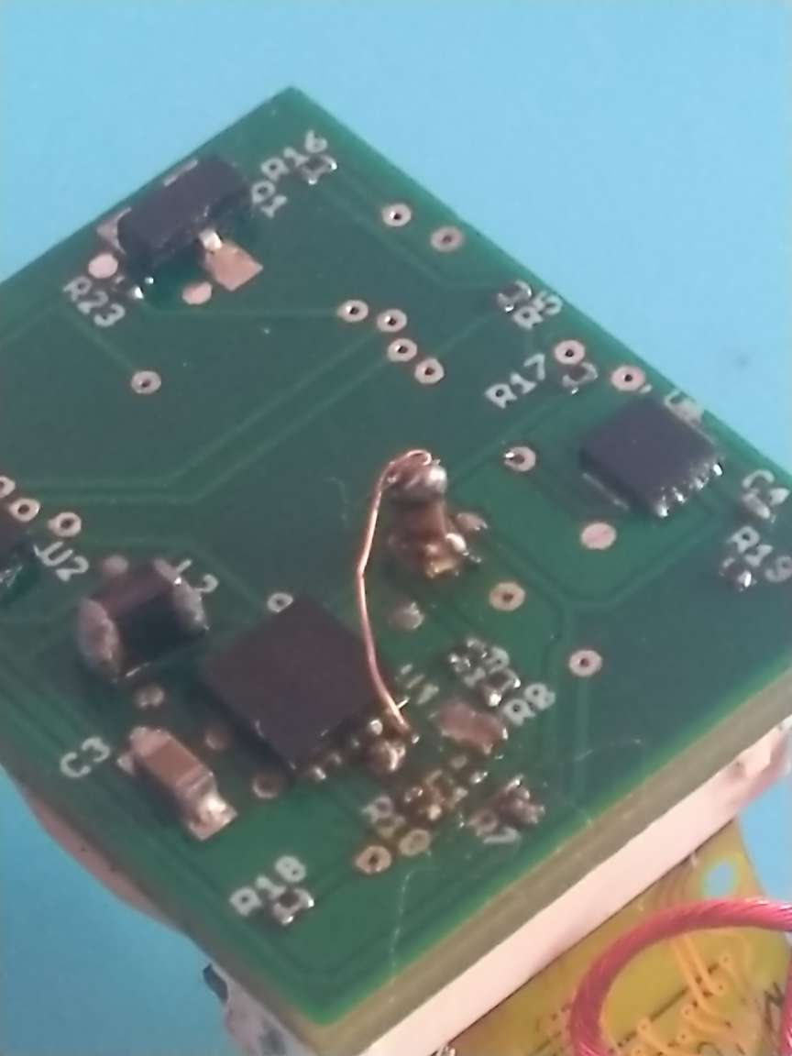3
- Size
  - The design is too large currently, we need to change to a design with
    - More sophisticated and compact components
    - A different design with relocation of the power pcb as shown below
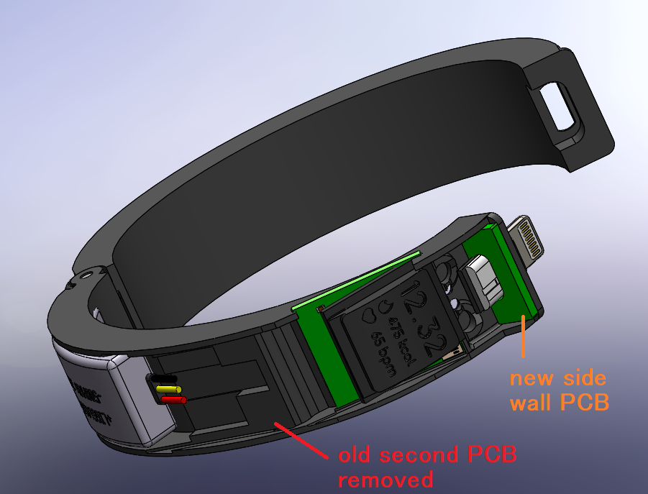
    - Direct solder of the display to the pcb (no socket)
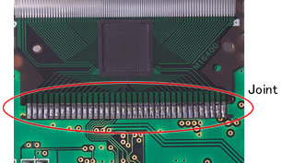
    - FPC ribbon cable connections for LiPo and Lightning cable
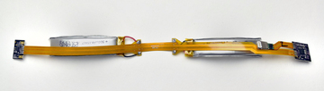
    - Direct solder of pogo pin to PCB
    - Removal of buttons on main board (and possible replace with bluetooth/wifi ability)
    - Flexible thinner PCB to hug the curved surface of the bracelet
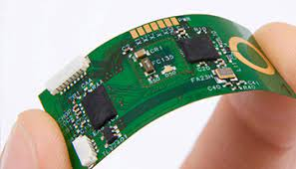
    - A removable programmer for when firmware development is finished

